Java Programming

Exam 1

March 31, 2017

Name ______________________

____ 1. A block can exist entirely within another block or entirely outside and separate from another block, and sometimes blocks can overlap.

____ 2. When you overload a Java method, you write multiple methods with a shared name.

____ 3. When you write your own constructors, you cannot write versions that receive parameters.

____ 4. If an integer is passed to a method with a double parameter, the double is promoted to an integer.

____ 5. Within any class or method, the code between a pair of curly braces is called a(n) ____.

|  |  |  |  |
| --- | --- | --- | --- |
| a. | overload | c. | scope |
| b. | argument | d. | block |

____ 6. A method can receive ____ arguments, even if it is defined as needing double arguments.

|  |  |  |  |
| --- | --- | --- | --- |
| a. | string | c. | constructor |
| b. | integer | d. | send |

____ 7. If a class’s only constructor requires an argument, you must provide an argument for every ____ of the class that you create.

|  |  |  |  |
| --- | --- | --- | --- |
| a. | parameter | c. | object |
| b. | type | d. | method |

____ 8. When you instantiate an object from a class, ____ is reserved for each instance field in the class.

|  |  |  |  |
| --- | --- | --- | --- |
| a. | a constructor | c. | memory |
| b. | a signature | d. | a field name |

____ 9. When calling this() from a constructor, it must be the ____ statement within the constructor.

|  |  |  |  |
| --- | --- | --- | --- |
| a. | first | c. | second |
| b. | ending | d. | indented |
|  |  |  |  |

10. What is the difference between class variables and instance variables?

11. int aMethod(int x)

void aMethod(int x)

In the above statements, explain why these two methods are illegal in the class.

. 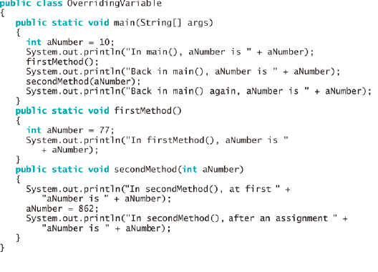

12. In the above code, what happens to the value of aNumber when the main() method is executed? What happens to the value of aNumber when the firstMethod and secondMethod methods are executed?

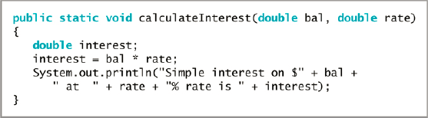

13. In the above code, what would happen if calculateInterest was passed the values of 100 for the bal and .10 for the interest rate? What would happen if calculateInterest was passed the values of 100 for the bal and 10 for the interest rate? Why is it a problem when these values are passed to the calculateInterest method, and what would be a possible solution to fix the problem?