1. A symbolic link is also known as a soft link and is depicted by an @ symbol appearing at the beginning of the filename when viewed using the ls -l command. True or False?
2. What was created to define a standard directory structure and common file location for Linux?
   1. FSH
   2. X.500
   3. FHS
   4. root directory
3. There is no real difference between the “S” and “s” special permissions when displayed using the ls -l command. One just means it is on a file and the other that it is on a directory. True or False?
4. The default permissions given by the system prior to analyzing the umask are _________________ for directories and _________________ for files.
   1. rw-rw-rw- and rw-rw-rw-
   2. rw-rw-rw- and r--r--r--
   3. rw-rw-rw- and rwxrwxrwx
   4. rwxrwxrwx and rw-rw-rw-
   5. rwxrw-rw- and rwx-rw-rw-
5. What must a user do to run cp or mv interactively and be asked if she wans to overwrite an existing file.
   1. There is no choice, because the new file will overwrite the old one by default.
   2. Type interactive cp or mv -interactive.
   3. Type cp -i or mv -i
   4. Type cp -interactive or mv -interactive
   5. Just type cp or mv, because they run in interactive mode by default.
6. The root user utilizes the chgrp command to give ownership of a file to another user. What must the root user do to regain ownership of the file?
   1. Run chgrp again listing the root user as the new owner.
   2. Nothing, because this is a one-way, one-time action.
   3. Have the new owner run chgrp and list the root user as the new owner.
   4. Run chown and list the root user as the new owner.
7. After typing the ls -F command, you see the following line in the output:  
   *-rw-r-xr-- 1 user1 root 0 Apr 29 15:40 file1*  
   What does this mean?
   1. User1 has read and write permissions, members of the root group have read and execute permission, and all others have read permissions to the file.
   2. Members of the root group have read and write permissions, user1 has read and execute permission, and all others have read permissions to the file.
   3. All users have read and write permissions, members of the root group have read and execute permissions, and user1 has read permissions to the file.
   4. User1 has read and write permissions, all others have read and execute permissions, and members of the root group have read permissions to the file.
8. After typing the command umask 731, the permissions on all subsequently created files and directories will be affected. In this case, what will be the permissions on all new files.
   1. rw-rw-rw-
   2. rwxrw-r--
   3. ---r--rw-
   4. ----wx--x
9. When you change the data in a file that is hard-linked to three others, _______________.
   1. only the data in the file you modified is affected
   2. only the data in the file you modified and any hard-linked files in the same directory are affected
   3. the data in the file you modified and the data in all hard-linked files are modified, because they have difference inodes
   4. the data in the file you modified as well as the data in all hard-linked files are modified, because they share the same data, and all have the same inode and file size
10. The command chmod 317 file1 would produce which of the following lines in 1s command?
    1. --w-r--rwx 1 user1 root 0 Apr 29 15:40 file1
    2. --wx--xrwx 1 user1 root 0 Apr 29 15:40 file1
    3. -rwxrw-r-x 1 user1 root 0 Apr 29 15:40 file1
    4. --w-rw-r-e 1 user1 root 0 Apr 29 15:40 file1
11. Which of the following commands will change the user ownership and group ownership of file1 to user1 and root, respectively?
    1. chown user1:root file1
    2. chown user1 : root file1
    3. This cannot be done, because user and group ownership properties of the file must be modified separately.
    4. chown root:user1 file1
    5. chown root : user1 file1
12. What does the /var directory contain?
    1. various additional programs
    2. spools and log files
    3. temporary files
    4. files that are architecture independent
    5. local variance devices
13. What does the mc command do? (Choose all that apply)
    1. It makes a volume.
    2. It makes a directory.
    3. It moves a directory.
    4. It moves a file.
14. A file has the following permissions: r----x-w-. The command chmod 143 would have the same effect as the command ______________. (Choose all that apply)
    1. chmod u+x-r, g+r-x, o+w file1
    2. chmod u=w, g=rw, o=rx file1
    3. chmod u-r-w, g+r-w, o+r-x file1
    4. chmod u=x, g=r, o=wx file1
    5. chmod u+w, g+r-w, o+r-x file1
    6. chmod u=rw, g=r, o=r file1
15. The which command __________________.
    1. can only be used to search for executables
    2. searches for a file in all directories, starting from the root
    3. is not a valid Linux command
    4. searches for a file only in directories that are in the PATH variable
16. Hard links need to reside on the same filesystem as the target, whereas symbolic links need not be on the same filesystem as the target. True or False?
17. When applied to a directory, the SGID special permission _____________.
    1. causes all new files created in the directory to have the same group membership as the directory, and not the entity that created them
    2. cannon be used, because it is applied only to files
    3. allows users to use more than two groups for files that they create within the directory
    4. causes users to have their permissions checked before they are allowed to access files in the directory
18. Which command do you use to rename files and directories?
    1. cp
    2. mv
    3. rn
    4. rename
19. What are the three standard Linux permissions?
    1. full control, read-execute, write
    2. read, write, modify
    3. execute, read, write
    4. read, write, examine
20. Given the following output from the ls command, how many files are linked with file1?  
    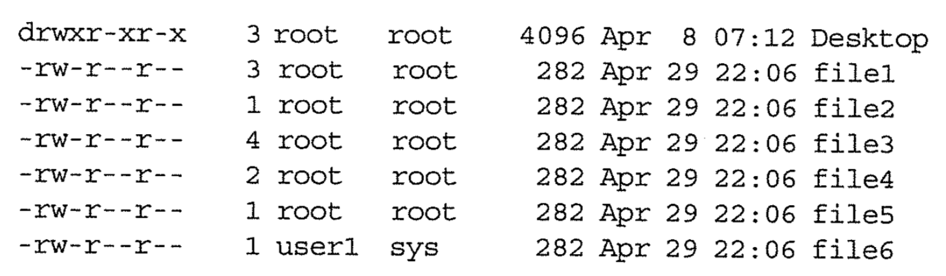
    1. one
    2. two
    3. three
    4. four